## CLASSES AND OBJECTS

## 

## Define a class student with the following data members:

## Admno integer, sname 20 character, eng, maths, science float, total float, ctotal() a function to calculate eng + maths + science.

## Public member function of class student:

## Takedata() function to accept values for admno, sname, eng, maths, science and invoke ctotal() to calculate total,

## Showdata() function to display all the data members on the screen

## Write a C++ program to create a class and invoke all the member functions.

## INPUT:

## #include<iostream.h>

## #include<conio.h>

## #include<stdio.h>

## class student

## {

## private:

## int admno;

## char sname[20];

## float eng,math,science;

## float total;

## float ctotal()

## {

## return eng+math+science;

## }

## public:

## void Takedata()

## {

## cout<<"Enter admission number ";

## cin>> admno;

## cout<<"Enter student name " ;

## gets(sname);

## cout<< "Enter marks in english, math, science ";

## cin>>eng>>math>>science;

## total=ctotal();

## }

## void Showdata()

## {

## cout<<"Admission number "<<admno<<"\nStudent name "<<sname<<"\nEnglish "<<eng<<"\nMath "<<math<<"\nScience "<<science<<"\nTotal "<<total;

## }

## };

## void main ()

## {

## clrscr();

## student obj ;

## obj.Takedata();

## obj.Showdata();

## getch();

## }

## OUTPUT:

## 

1. Define a class worker with the following specification

Roll_no integer, wno integer, wname 25 character, hrwrk float, wgrate float, totwage float and function calcwg() to find totwage=hrwrk*wgrate with float return type.

Public member:

In_data() a function to accept values of wno, wname, hrwrk, wgrate and invoke calcwg() to calculate totpay.

Out_data() a function to display all the data members on the screen you should give definitions of functions.

Write a C++ program to create a class and invoke all the member functions.

## INPUT:

## #include<iostream.h>

## #include<stdio.h>

## #include<conio.h>

## class worker

## {

## int wno;

## char wname[25];

## float hewrk,wgrate;

## float totwage;

## float calcwg()

## {

## totwage = hewrk*wgrate;

## return totwage;

## }

## public:

## void in_data()

## {

## cout<<"Enter worker number:"; cin>>wno;

## cout<<"enter worker name:"; gets(wname);

## cout<<"Enter hours worked: "; cin>>hewrk;

## cout<<"Enter wage rate per hour:"; cin>>wgrate;

## calcwg();

## }

## void out_data()

## {

## cout<<"Worker number:"<<wno<<endl;

## cout<<" Worker name:"<<wname<<endl;

## cout<<" Hours worked:"<< hewrk<<endl;

## cout<<" Wage rate per hour:"<< wgrate<<endl;

## cout<<" Total wage:"<<totwage<<endl;

## }

## };

## void main()

## {

## clrscr();

## worker obj;

## obj.in_data();

## obj.out_data();

## getch();

## }

## OUTPUT:

## 

## A class CLOCK has the following members:

## Data member:  hour of type integer, minute of type integer.

## Member functions: readtime(int h, int m); showtime()  to display data member, addtime(time T1, time T2).

## Write a program to input two different objects FT and ST, print their sum (assume 24 hr. clock time).

## e.g. input FT=6 hrs. 35mins, ST=3hrs 45 min then output T=FT+ST=10hrs 20min.

## INPUT:

## #include<iostream.h>

## #include<conio.h>

## class Time

## {

## private:

## int hours;

## int minutes;

## public:

## void readTime(int h,int m)

## {

## hours=h;

## minutes=m;

## }

## void showTime()

## {

## cout<<"\nHours : "<<hours;

## cout<<"\nMinutes : "<<minutes;

## }

## Time addTime(Time t1, Time t2)

## {

## Time t3;

## int temp_min;

## temp_min=t1.minutes+t2.minutes;

## t3.minutes=temp_min%60;

## t3.hours=t1.hours+t2.hours+temp_min/60;

## return(t3);

## }

## };

## void main()

## {

## Time obj1,obj2,obj3;

## int hrs,min;

## clrscr();

## cout<<"Enter the time in hh mm format\n";

## cin>>hrs>>min;

## obj1.readTime(hrs,min);

## cout<<"\nEnter the time in hh mm format\n";

## cin>>hrs>>min;

## obj2.readTime(hrs,min);

## cout<<"\nFirst time is : \n";

## obj1.showTime();

## cout<<"\n\nSecond time is : \n";

## obj2.showTime();

## obj3 = obj3.addTime (obj1,obj2);

## cout<<"\n\nResultant time is : \n";

## obj3.showTime();

## getche();

## }

## OUTPUT:

## 

1. A class serial has the following data members: Scode integer, title 20 character, duration float, noofepisodes integer and members functions:

(i) init() to initialize duration as 30 and noofepisodes as 10

(ii) Newserial() function to accept values for serialcode and title

(iii) Otherentries() function to assign the values of all data members with the help of

corresponding values passed as parameters to this function.

(iv) Dispdata() function to display all the data members on the screen.

Write a C++ program to create a class and invoke all the member functions.

**INPUT:**

#include<iostream.h>

#include<conio.h>

#include<stdio.h>

class serial

{

private :

int serialcode;

char title[20];

float Duration;

int Noofepisodes;

public :

void init( )

{

Duration = 30;

Noofepisodes = 10;

}

void Newserial ( )

{

cout<<"enter serialcode ";

cin>> serialcode;

cout<<"enter serial title ";

gets(title);

}

void Otherenteries( int x , int y )

{

Duration = x;

Noofepisodes = y;

}

void dispdata( )

{

cout<<"Serial code "<<serialcode<<endl;

cout<<"Serial title "<<title<<endl;

cout<<"Duration of the serial "<<Duration<<endl;

cout<<"No. of episodes "<<Noofepisodes<<endl;

}

};

void main()

{

clrscr();

serial s;

int a,b;

s.init();

s.Newserial();

cout<<"Enter the duration and number of episodes ";

cin>>a>>b;

s.Otherenteries(a,b);

s.dispdata();

getche();

}

**OUTPUT:**

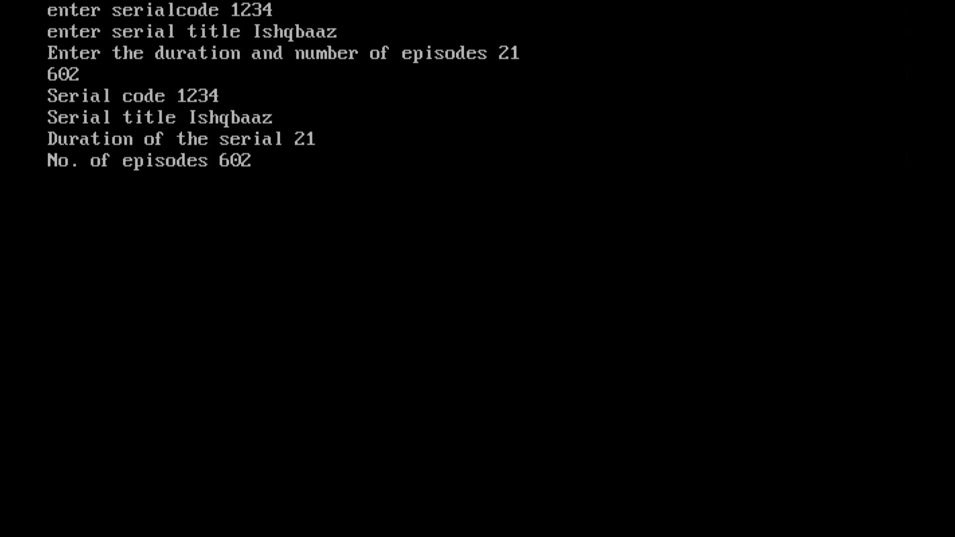

1. A class student has three data members name, roll number, marks of 5 subjects and two member functions to accept data and to assign streams on the basis of table given below. Develop a C++ program to accept the data and print the stream:

Average Marks                  Stream

96% or more                      Computer Science

91% - 95%                         Electronics

86% to 90%                       Mechanical

81% to 85%                       Electrical

76% to 80%                       Chemical

71% to 75%                       Civil

**INPUT:**

#include <iostream.h>

#include <string.h>

#include <conio.h>

#include <stdio.h>

class student

{

char name[50];

int rno;

float marks[5];

char stream[25];

void assign()

{

float average = avg();

if(average>=70&&average<=76)

strcpy(stream,"Civil");

else if(average>=75&&average<=81)

strcpy(stream,"Chemical");

else if(average>=80&&average<=86)

strcpy(stream,"Electrical");

else if(average>=85&&average<=91)

strcpy(stream,"Mechanical");

else if(average>=90&&average<96)

strcpy(stream,"Electronics");

else if(average>=96)

strcpy(stream,"Computer Science");

else

strcpy(stream,"No stream");

}

public:

void input();

void display()

{

cout<<"\nRoll no: "<<rno<<endl;

cout<<"Name: "<<name<<endl;

cout<<"Average : "<<avg()<<" %"<<endl;

cout<<"Stream: "<<stream<<endl;

}

float avg();

};

float student::avg()

{

float average=0;

for(int i=0;i<5;i++)

average+=marks[i];

average/=5;

cout<<"Average = "<<average<<endl;

return (average);

}

void student::input()

{

cout<<"Enter roll no\n";

cin>>rno;

cout<<"Enter name\n";

gets(name);

cout<<"Enter marks in five subjects\n";

for(int i=0;i<5;i++)

cin>>marks[i];

assign();

}

void main()

{

clrscr();

student stu;

stu.input();

stu.display();

getche();

}

**OUTPUT:**

